Setting Underline in iAccess for Windows
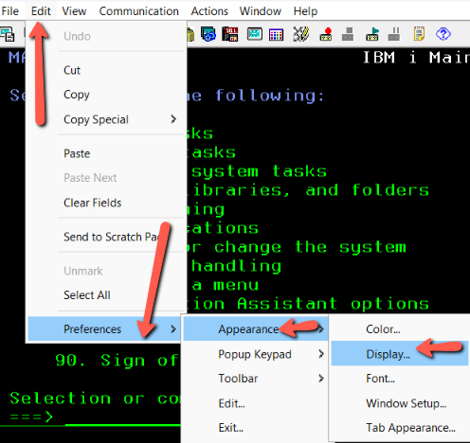
Cursor:

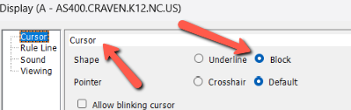

This makes the cursor a Block instead of an Underline.
This puts the ruler on your screen.
