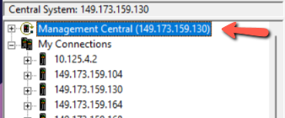

Right mouse click on Management Central
Choose Change Central System
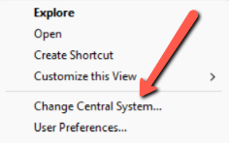
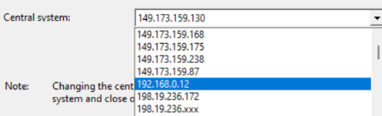
Drop down and choose the Ensono IP address of your system.

