If you receive “Waiting on reply on message queue qsysopr”

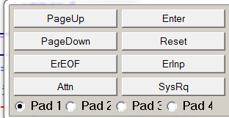



This displays the system operator messages.
Answer the message and then press F3/F12 back perhaps a couple of times.

