Configuring PDF session to print from AS400

Download PDF software (we recommend CutePDF but if your district has policy on another it will work) | www.cutepdf.com  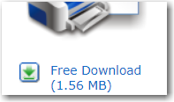
Configure PC 5250 printer session pointing to this PDF printer session | 
 | 
 | 
Be sure and choose a printer name (workstation ID) that has NOT been used before or you will get a “disconnected” screen. | 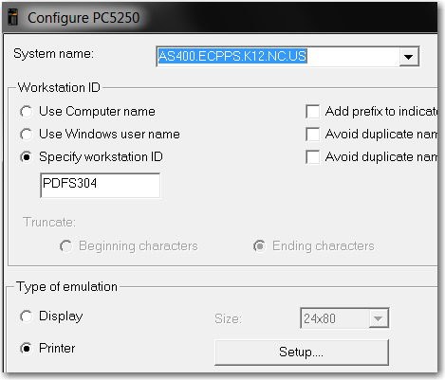
 | 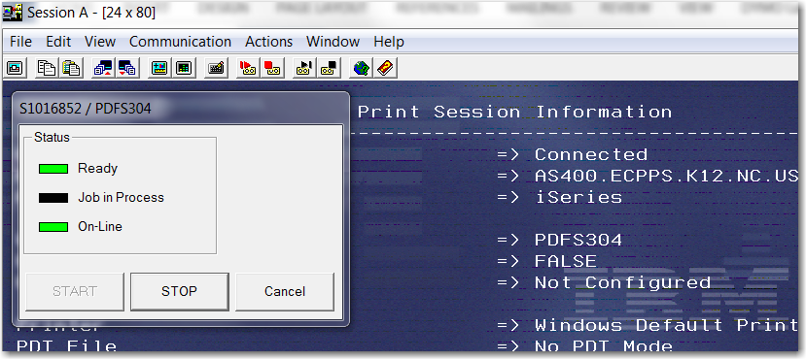
Click File, Printer setup | 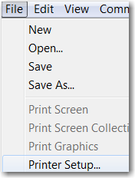
Pick the PDF software  Click OK | 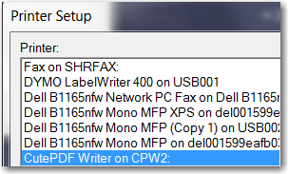
Click File, Page Setup | 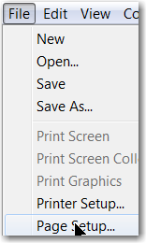
It’s best to try Landscape and use best fit scaling.  Test with a report to see results. | 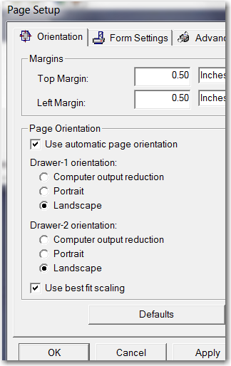
Click file, save as and name the session, drag copy to desktop. | 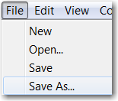
Note your path name – this may be a “roaming path name” – this is mine: | 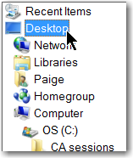
This could be your path: | 