Creating PDF printer sessions on the AS400
Click on IBM iSeries Access for Windows, Start or Configure Session, New Session | 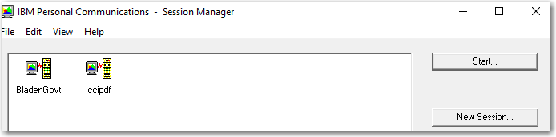
Fill in the following:  AS400 PDF printer name  Click on Setup | 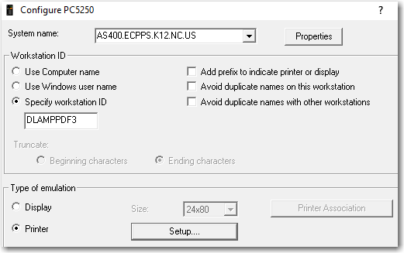
Type AS400 Userid to receive messages about the printer. Click OK. | 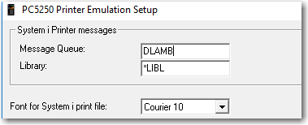
Session will create (I used my own name here) | 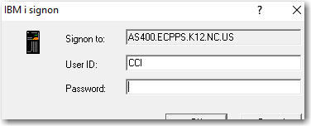  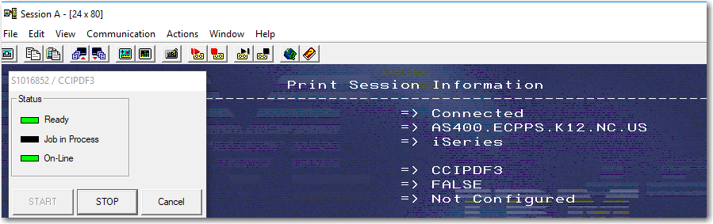
The next thing to do is configure the PDF
Click File, printer setup | 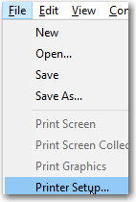
Choose this:  Microsoft Print to PDF on Portprompt  If this does not work, try this:  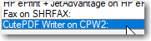  You will need to download this from www.cutepdf.com   | 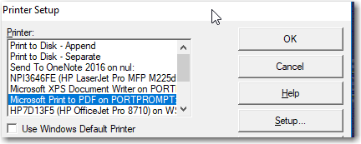
Then:  File, Page setup | 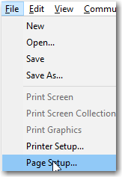
Set screen prompts as follows: | 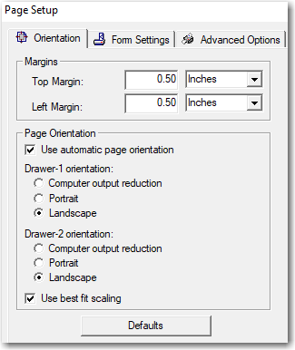
File, save as, this is where the file is “normally” saved: | 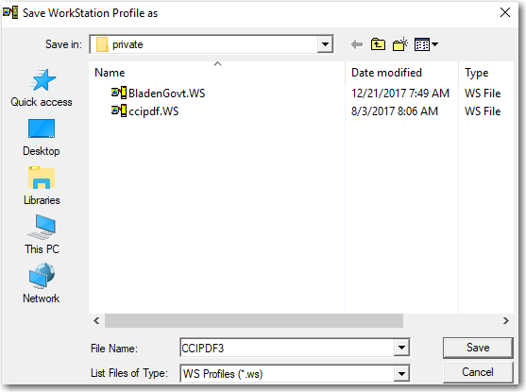  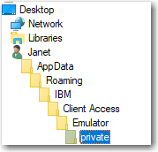  This is “my” personal roaming path (Janet) is the PC I am on.
Drag the icon with right mouse to desktop to create a shortcut | 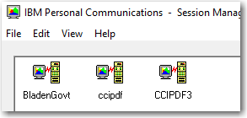
Test the printer | 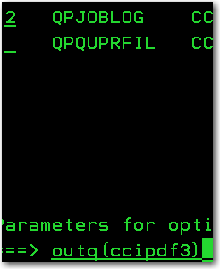
Printer has a message the first time: | 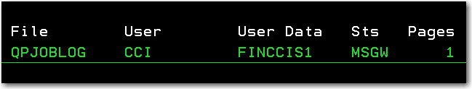
Answer the message with a G
Screen will pop up asking where you want to save the document – I am saving to my desktop | 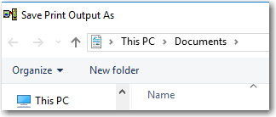
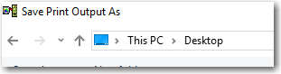

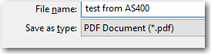

Double click on the icon on the desktop to verify. If it does not open with Adobe Acrobat, need to modify so Microsoft Edge does not open. | 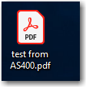
This was my sample file | 