Reprocessing Checks or POs back through Formserver (example)
If POs or checks have already been printed and you just want them in Ondemand, be sure and put the printer on HOLD first.  Wrksplf (username) – to get output queue name – write it here:  Fs4monoq | 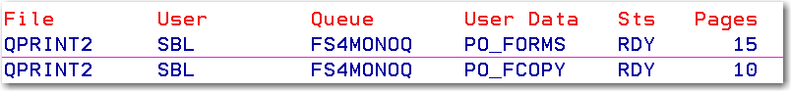  F11 will show you the form type  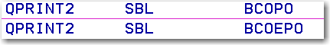
Go fs4menu, option 4, F4, choose which form to process based on first step | 
Doing the first one – 15 pages
Press Enter – note this may NOT be the output queue where the files are! Press F6 to choose the output queue.   | 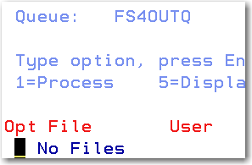  
Look for the one that is 15 pages – and the form type above (the date and the number of pages may assist you in determining the correct file) – you can also put option 5 by the file to view it.
 | 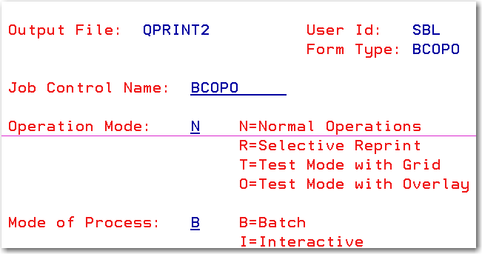
 | Press enter.

