Printer sessions
There are 3 options when configuring printers: The windows printer driver, the pdt, and host print transform. Each will be covered here.
Windows printer driver
Click Start, Programs, iSeries Access, emulator, start or configure session, new session | 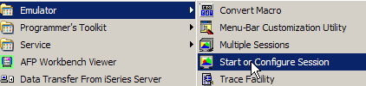
Click New session | 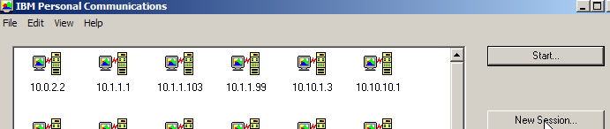
Set up SSL (click properties) | 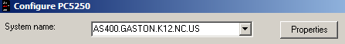
Use SSL | 
Name the session (i.e. S408P1). | 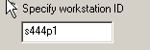
Select printer radio button, select setup. Use the user’s name for message queue. Click ok. | 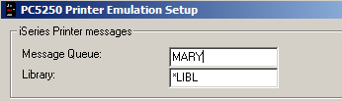
Printer is configured | 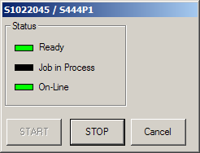
Change the workstation display name from “Session B” to Printer session | 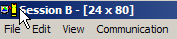
Edit Prefs, appearance, window setup | 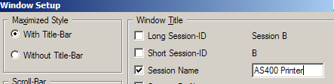
Session name is now meaningful. | 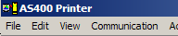
Click on File, Printer setup, select windows printer (either parallel printer attached or network printer) | 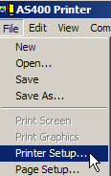
Select printer. Optionally choose use Windows default printer if desired. | 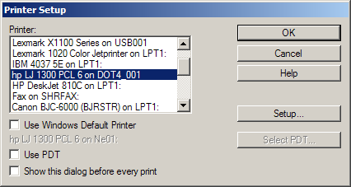
Click on File, Page setup, try the following combinations | 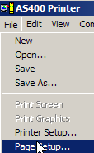
Page orientation, check the “use automatic page orientation”, computer output reduction, and use best fit scaling. Click ok. | 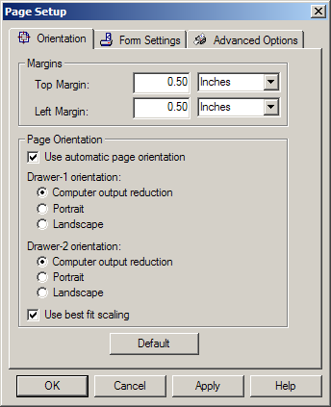
Test with a real report (something that’s 132 characters across) - | Type DSPJOBLOG and press F4 and type *PRINT for output parameter to generate a joblog for – this will generate a “system” test, not a user report.
Type WRKSPLF to see the report, option 2 by the report, on the command line type OUTQ(nameofprinter) save(*YES) | 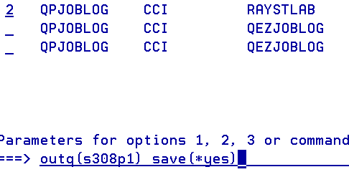
Second choice for printing is the PDT
Click File, Printer setup, choose “use PDT”. | 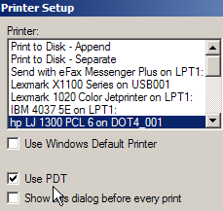
Click “Select PDT” | 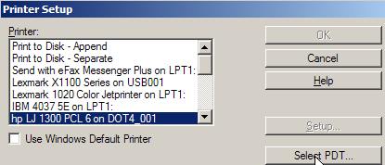
Usually something close to the printer you are working with, best choices are usually basic_ascii or hppcl5.pdt. Refer to the IBM documentation found on the Cook consulting website for specifics. | 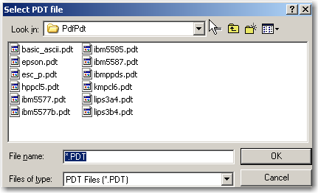
Click ok
Click ok again | 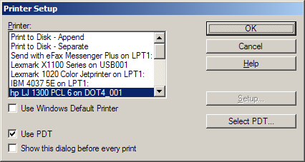
Test print again.
Third choice: Host print transform
Uncheck the PDT option, click ok.
Click Communication, configure | 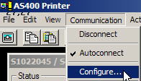
Select “setup” | 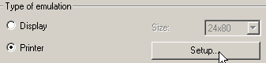
Click “transform print data to ASCII on iSeries. Pick closest printer from the list. | 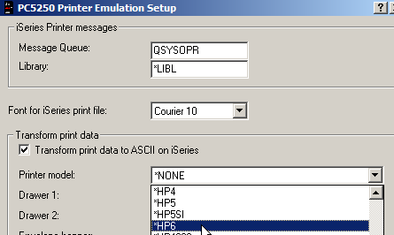
Click ok | 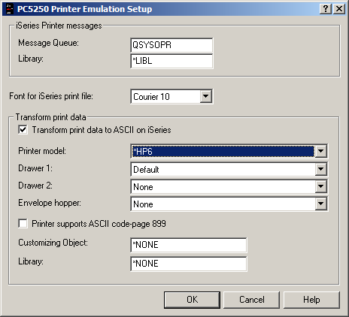
Click ok to this message – session has to be disconnected and reconfigured to do host print transform | 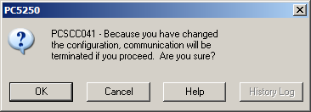
Test print again, and to verify this change, type wrkdevd “printername”on a command line, i.e. wrkdevd s444p1.
Option 5 to view the device | 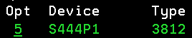
Page down to see “host print transform” | 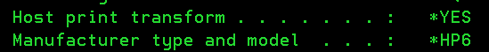
Fourth option: use a WSCST (call the support desk for details).

