Checking the status of cache battery
Sign in to System Service Tools | STRSST on the command line
Userid is QSECOFR
Password is communicated to you verbally – please document and save! | 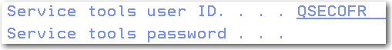
Choose option 1 | 
Option 7, Hardware service manager | 
Option 9, Work with cache battery packs
The following screen will depend on how many batteries you have on your system. | 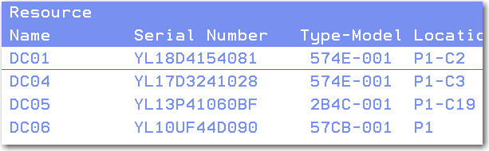
Option 5 is displayed – DO NOT choose any other option
This is when the battery will be in error:  F12 to back out | 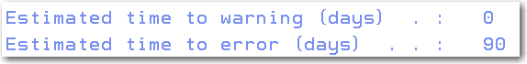
Repeat for each battery. | 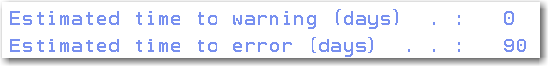
This battery is fine – no warning and lots of days until the error. | 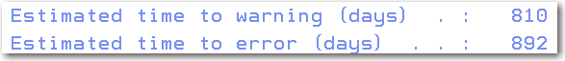
To exit STRSST, F3 3 times. | 