Changing IP addresses on iSeries Printers
Command to see list of IP addressable printers | wrkdevd *lanprt
Option 8 by the printer to see the status | 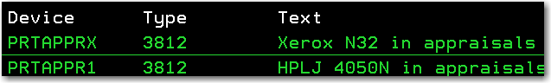
8 | 
If writer is started, end writer | Endwtr (writername) *immed
Then vary off the printer with option 2
Status will go to varied off
F12 to go back to description
Option 2 to change
F10 and page down until see the IP address – change it: | 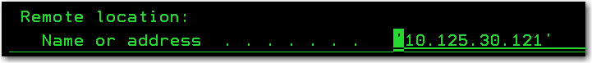
Press enter.
Message at bottom of screen
Option 8 by printer again to vary on. | 
Vary on. | 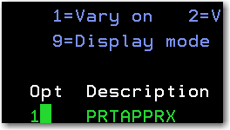
Start printer writer.
Command: | Strprtwtr prtapprx
Change the IP address physically on the printer to match what you changed it to on the AS400/iSeries.
Test by sending a report to the printer
Command: | Wrksplf
Option 2 by the spooled file and on the command line type outq(nameofprinter) | 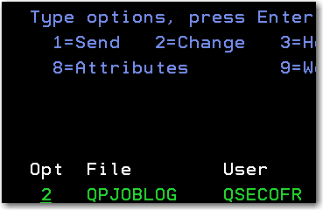  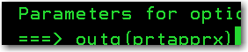
Any questions, contact supportdesk@cookconsulting.net

