Creating an iSeries Connection in Navigator
Open up iSeries Navigator |   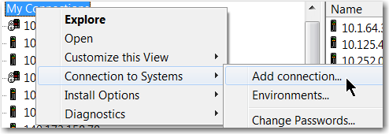
Put the System name in (if using spreadsheets, do NOT put the IP address in)  Click Next | 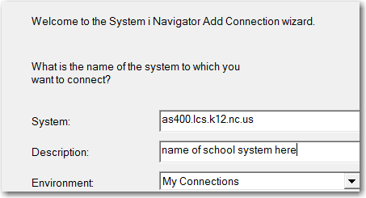
Choose second radio button, put the user’s AS400 user profile in  Click Next | 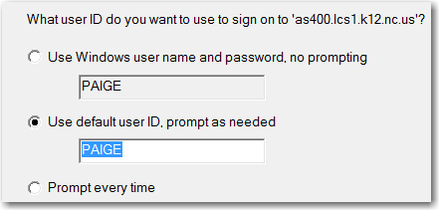
No not verify, click finish | 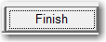
Right click on the system name, choose properties | 
Choose Secure Sockets | 
Choose download | 
Sign on to the AS400 if prompted | 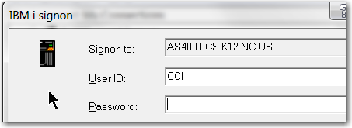
Password is ca400 | 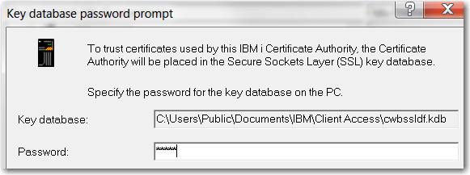
Click ok | 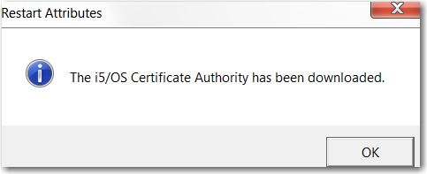
Close and reopen Navigator | Notice the lock

